WESTERN PROVINCE 
RUSIZI DISTRICT
TERM I Midi Term Test
SECTOR: ICT and MULTIMEDIA
TRADE: Software Development
TVET LEVEL: 3
MODULE TITLE: SWDWD301 WEBSITE DEVELOPMENT
ACADEMIC YEAR: 2025-2026
DURATION: 3 HOURS
DATE:……/……./2026
MARKS: ……../100

INSTRUCTIONS TO CANDIDATES:
This Exam paper is composed of Three Sections (A, B,C).
Follow the instructions given below, and answer the indicated
Section A: 17 questions (attempt all)/ 55marks
Section B: 5 questions (attempt only three) /30marks
Section C: 2 questions (attempt only one) / 15marks

SECTION A: Attempt All questions /55 Marks

01 | Choose the letter corresponding to the correct answer:  1. What is a keyboard?  A) A device used to display images  B) A device used to input text and commands into a computer  C) A device used to output sound  D) A device used to store data  2. Which key is typically found directly below the 'Q' key in a QWERTY layout?  A) A  B) W  C) Z  D) S | 4marks
02 | Answer by true or false:  a. Alphanumeric keys on a keyboard include letters, numbers, punctuation marks, and symbols, similar to those found on a traditional typewriter.  b. The Ctrl, Alt, and Esc keys are considered control keys that can only be used in isolation without any other keys.  c. The function keys (F1 to F12) perform the same tasks across all software applications, ensuring consistent functionality.  d. The numeric keypad is designed to facilitate quick number entry and is arranged similarly to a conventional calculator. | 4marks
03 | Match column A to B  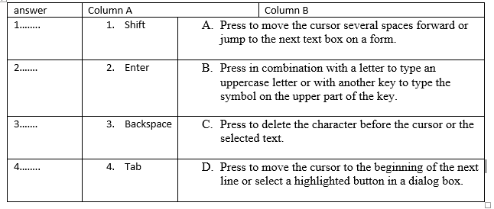 | 4marks
04 | In Microsoft Word, what key combination would you use to move the cursor to the beginning of the previous word?  - A) Ctrl + Right Arrow  - B) Ctrl + Left Arrow  - C) Ctrl + Down Arrow  - D) Ctrl + Up Arrow | 3marks
05 | Which key combination is used to open a new private browsing window in most web browsers on a Windows device?  - A) Ctrl + N  - B) Ctrl + Shift + P  - C) Ctrl + Shift + N  - D) Ctrl + Alt + N | 3marks
06 | What does WPM stand for in typing speed measurement?  - A) Words Per Minute  - B) Words Per Measurement  - C) Words Per Mark  - D) Words Per Module | 3marks
07 | What is the purpose of using a key combination like pressing the power button and volume down button together on a mobile device?  - A) To increase the volume  - B) To take a screenshot  - C) To turn off the device  - D) To open the camera | 3marks
08 | Complete with: posture, words, people  - Ergonomics is the process of designing workplaces and products so that they fit the __________ who use them.  - Good __________ is a position in which the body is aligned to put the least amount of strain on the muscles, joints, and ligaments.  - Typing speed is typically quantified in terms of __________ per minute (WPM) or characters per minute (CPM). | 3marks
09 | What is a webpage?  A. A collection of related web pages located under a single domain name  B. A software application for accessing information on the World Wide Web  C. A document on the World Wide Web that is identified by a unique URL  D. A tool used for writing and editing text and code | 3marks
10 | What is a website?  A. A single document on the World Wide Web  B. A collection of related web pages located under a single domain name  C. A tool used for browsing the internet  D. The address used to access a webpage | 3marks
11 | What is a web browser?  A. A document on the World Wide Web that is identified by a unique URL  B. A collection of related web pages located on server and delivered to the client  C. A software application for accessing and viewing information on the World Wide Web  D. A tool used for reading music and video on computer displays | 3marks
12 | What is a text editor?  A. A document written using symbols and graphics  B. A collection of software that are used to write complicated scripts in notepad  C. A tool used for drawing graphics on webpage the internet  D. A tool used for writing and editing text and code | 3marks
13 | Which ergonomic tip helps reduce neck and eye strain?  - A) Adjusting the height of the chair  - B) Placing the monitor at eye level  - C) Keeping the keyboard far away  - D) Taking breaks every hour | 3marks
14 | Which of the following are examples of web browsers?  A) Safari  B) Edge  C) Atom  D) Opera | 3marks
15 | When installing software from a storage drive, what is the first step?  A) Open a web browser  B) Insert the storage drive into the computer and locate setup  C) Run an antivirus scan  D) Open the command prompt | 3marks
16 | Complete with: abilities,visibility, users  - Search Engine Optimization (SEO) refers to the practice of optimizing a website to improve its ……………………………………… and ranking on search engine results pages (SERPs) such as Google, Bing, and Yahoo.  - Web accessibility ensures that websites and web applications can be used by people with various ………………………………  - HTML (HyperText Markup Language) plays a crucial role in web accessibility by providing the structural foundation that ensures content is accessible to all ………………………….., including those with disabilities. | 3marks
17 | What is the primary goal of typing techniques?  - A) To type as slowly as possible  - B) To improve efficiency, accuracy, and speed of typing  - C) To memorize keyboard layouts  - D) To minimize the use of fingers | 4marks

Section B: Attempt any three (3) questions (30 marks) _____________________________________________________________________________
18 | List and explain any 5 types of website | (10 marks)
19 | write the structure of an html document | (10 marks)
20 | Discuss the functions of websites | (10 marks)
21 | Suggest the output of the following HTML codes:  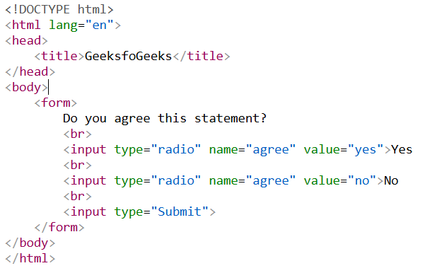 | (10 marks)
22 | Discuss the evolution of HTML | (10 marks)

Section C: Attempt only one (1) question /(15 marks)
23 | Write HTML codes to display the following table: 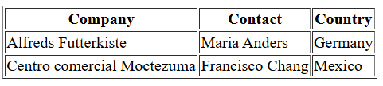 | (15marks)
24 | Write HTML codes to display the following form:  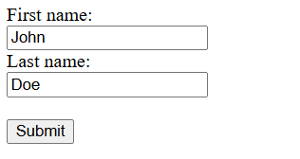 | (15marks)

END OF ASSESSMENT

